Overview
Postsecondary institutions that are members of Universities Canada or Colleges and Institutes Canada are invited to submit multi-year project proposals seeking funding up to $300,000 CAD.
QES 2025 will support projects that focus on the adaptation, response, and resilience to a changing climate. This includes (but is not limited to) projects focused on biodiversity; agriculture; energy; climate and public health; economic impacts of climate change; air quality; community resilience; education; ecosystems and water quality.
Canadian postsecondary institutions may partner on a joint proposal, however each institution may be the lead applicant on only one submission. Approximately $6,000,000 CAD is available through this competition.
Priority will be given to projects that focus on diversity and inclusion and result in a strengthened impact to local and global communities by young leaders.
All funded activities must be completed by December 31, 2028.
Please do not add any links to external documents or websites in your answers. These will not be taken into consideration.
Quick links:
Program Guidelines
Frequently asked questions
Summary of project criteria:
- Postsecondary institutions that are members of Universities Canada or Colleges and Institutes Canada may submit a proposal to the QES program.
- QES 2025 will support projects that focus on the adaptation, response, and resilience to a changing climate. All funded activities must be completed by December 31, 2028.
- Canadian postsecondary institutions may partner on a joint proposal however each institution may be the lead applicant on only one submission.
- Projects will support international study, research, or internships for Canadian students and/or scholarships for incoming international graduate students to study or do research in Canada.
- All QES funded activities must be for academic credit/recognition.
- Applications must demonstrate a partnership between a Canadian postsecondary institution and a partner institution/organization in at least one of the eligible countries.
- The program will require all scholars to participate in leadership development, networking, and community engagement activities.

PROPOSAL REQURIEMENTS:
- Complete the application form.
- Upload a completed Budget Form. The form must be submitted as an Excel document.
- For all scholars, upload the letter(s) of support from the partner organization(s).
APPLICATION COMPONENTS

Applicant
Prefix:
First Name:
Last Name:
Email:
General Information
Please provide the required information below.
1.1 Canadian postsecondary institution
1.2 Are you partnering with another Canadian postsecondary institution for this proposal?

Yes
No

1.3 Are you partnering with a Canadian organization other than a postsecondary institution for this proposal?

Yes
No

Project
2.1 Project title

2.2 Project summary: Please summarize your project. Clearly and succinctly describe your objectives, partners, specific activities, and expected results. Please note that this summary may be used for program-related communication purposes (150 words)

2.2.1 Please explain how your project and/or partners will focus on diversity and inclusion, with specific examples (250 words)

2.3 Please explain how your project will focus on the adaptation, response and resilience to a changing climate, with specific examples. This includes (but is not limited to) project activities related to biodiversity; agriculture; energy; climate and public health; economic impacts of climate change; air quality; community resilience; education; ecosystems and water quality. (250 words)

2.3.1 Please explain how your project will enhance academic diplomacy. Academic diplomacy refers to the impact of the project activities that carry benefits beyond academia and across individuals and communities. For more information on the term, please refer to the glossary of terms found in the Program Guidelines. (250 words)

2.3.2 Many QES funded projects are highly interdisciplinary, involving many different actors and organizations related to the overarching topic (in the case of QES 2025, the adaptation, response, and resilience to a changing climate). Does your project meet this definition of interdisciplinary?

Yes

No

2.4 Previous experience

Describe your institution’s experience working on projects of similar complexity and scope. Please provide specific examples including results (250 words).

Scholar Data
3.1 Country(ies) involved

Indicate the countries involved in your project.

3.2 Number of Queen Elizabeth Scholars

Select the type of scholars involved with your project. Enter the number of anticipated scholars by type (Canadian outbound or international inbound). Please note that: each scholar is to be accounted for one time throughout the duration of the project (2025 - 2028).

_ Outbound Canadian students
_ Inbound international students

Project Partners holar ta
4.1 Does your project proposal include outbound Canadian students?

Yes
No

4.2 For inbound international students, will your QES project build on an existing partnership with an institution/organization?

Yes
No

4.3 Will your QES project develop new partnerships?

Yes
No

Results and Risks
5.1 Rationale

Provide a rationale for your proposed project. Explain how your approach, partnerships and activities will contribute to meeting the objectives and outcomes of the QES program (300 words)

5.2 Explain how your proposed project will have an impact on local and global communities. (150 words)

5.3 Results

Referring to the logic model below, add three specific activities for each Immediate Outcome that will contribute towards the achievement of results.

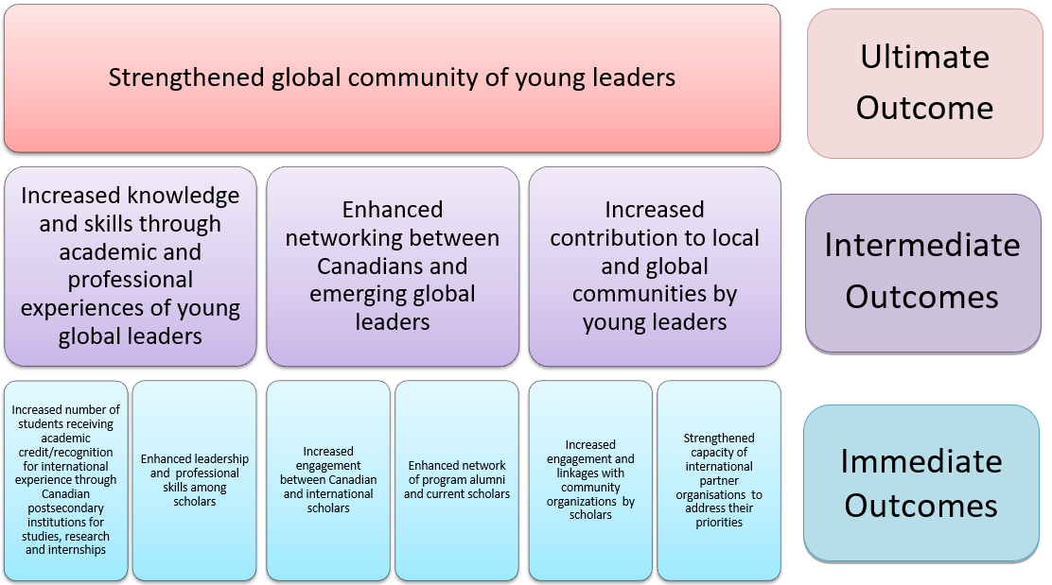
Enter 3 activities per immediate outcome below. (75 words max/activity)
A. Increased number of students receiving academic credit/recognition for international experience through Canadian postsecondary institutions for studies, research and internships.
1: | 75 words left
2: | 75 words left
3: | 75 words left
B. Enhanced leadership and professional skills among scholars.
1: | 75 words left
2: | 75 words left
3: | 75 words left
C. Increased engagement between Canadian and international scholars.
1: | 75 words left
2: | 75 words left
3: | 75 words left
D. Enhanced network of program alumni and current scholars.
1: | 75 words left
2: | 75 words left
3: | 75 words left
E. Increased engagement and linkages with community organisations by scholars.
1: | 75 words left
2: | 75 words left
3: | 75 words left
F. Strengthened capacity of international partner organisations to address their priorities.
1: | 75 words left
2: | 75 words left
3: | 75 words left
Risk Assessment
5.4 Risks

On a scale of 1 to 5, with 1=Low Risk and 5=High Risk, list three to five potential risks in implementing the project and achieving the expected results. Consider operational, financial, reputational and safety risk (s) with respect to the scholars, Canadian postsecondary and partner organization (s). Please provide specific strategic to mitigate each risk.

Rank | Risk | Mitigation Strategy | Impact | Likelihood

Project Management and Methodology
Describe your management strategy for outbound Canadian students as well as for inbound international students. Describe each of the following: recruitment, selection, pre-departure preparation, monitoring, nurturing a sense of belonging to the QES program and ongoing support strategies for the selected recipients. Please outline how you will aim for a reasonable gender balance and encourage diversity and inclusion.
6.1 Recruitment and selection

Describe your recruitment and selection strategies (350 words).

6.1.2 Describe your strategy to encourage diversity and inclusion (150 words).

6.1.3 Describe how you will aim for a reasonable gender balance (100 words).

6.2 Pre-departure/arrival training

Provide specific information on the pre-departure (Canadian students)/arrival in Canada (international students) training offered to QES scholars (300 words).
6.3 Monitoring and support

Please provide specific information on how you will monitor and provide ongoing support to QES scholars (200 words).

6.3.1 Please provide specific information on how you will monitor and provide support to QES scholars in the case of mental health issues (200 words).

6.3.2 Please describe how your institution will ensure student safety during their QES experience (in Canada and abroad) (150 words).

6.4 Belonging to the QES program

Describe specific and measurable activities offered by your postsecondary institution to help both Canadian and international scholars nurture a sense of belonging to the QES program, before, during and after their award (300 words).
6.6 Community engagement

Describe how you will ensure that all QES scholars, Canadian and International, undertake, community engagement activities during their QES award. Community Engagement means volunteering in the community above and beyond the internship/study/research activities found by the QES and are to be undertaken while receiving QES funding (200 words).

6.7 Networking activities

Describe specific and measurable activities to be organized by your postsecondary institution that will connect current QES scholars with each other as well as with QES alumni, across all projects (200 words).

6.8 Academic credit/recognition

All students must receive academic credit/recognition for the successful completion of their QES funded activities. How the credit/recognition is attributed is to be determined by the Canadian postsecondary institution. Possibilities include specific course credit, directed reading, co-curricular, co-op credit etc. In the case of incoming scholars undertaking short term study or research, QES funded activities must be directly linked to the graduate program in which they are registered in their home country.

6.9 Knowledge sharing

I confirm that our project will participate in knowledge sharing activities throughout the program implementation period to impart insights and learnings from the project with other Canadian postsecondary institutions.

I confirm that all QES scholars will receive academic credit/recognition

Cost Effectiveness and Budget
7.1 Cost effectiveness and budget

Referring to your completed budget form, explain how this proposal provides good value for money. Explain the assumptions behind both the project budget and the postsecondary institution/partner contributions and clearly list what expenses are to be charged to the QES program. Additionally, please provide details of all items included in “Other Contributions” (500 words).

Authorization, Privacy & Consent
8.1 Authorization
Please provide the name of the Signing Authority at your university.
Signing Authority Name:
Email Address:
I confirm that I have discussed this proposal with the signing authority above, for, and have their approval to submit this project proposal.

8. 2 Privacy
Universities Canada is strongly committed to your privacy and complies with the Canadian Personal Information Protection and Electronic Documents Act (PIPEDA), which regulates data privacy across Canada. If you have any questions or concerns about the privacy of your information, please contact Universities Canada’s Privacy Officer by calling (613) 563-1236 or by writing to: Privacy Officer at 1710-350 Albert Street, Ottawa, ON K1R 1B1.
Universities Canada’s privacy policy is posted on our website.
Below is an overview of how Universities Canada uses and shares the information collected in this application.
Information collection
Universities Canada only collects the information required to:
- Process and review your application;
- Select recipients.
Information sharing
In the course of administering your application, Universities Canada may share your personal information with selection committee members and contracted system administrators. Universities Canada will not use or share your information unless required or authorized by law, or unless we get your permission.
Since this program is funded by Rideau Hall Foundation (RHF) personal information will also be shared with RHF for the purposes of program administration and evaluation. When information is shared, it is administered in accordance with the Privacy Act (R. S.C., 1985, c. P-21). You have a right under the Access to Information and Privacy Act (R.S.C., 1985, c. A-1) to obtain access and correction to that information from the Government of Canada. If you are not satisfied with the response to any privacy concerns, or if you wish to file a complaint about the handling of your information, you may wish to contact the Office of the Privacy Commissioner of Canada.
Information use
Universities Canada and/or Rideau Hall Foundation may use your personal information to contact you in the future to make sure the program is meeting its goals. Participation in follow up surveys or interviews is voluntary and whether you choose to participate will not affect your eligibility to participate in the program.
Access to your personal information
You have the right to access your personal information stored by Universities Canada at any time by contacting the QES program staff. Universities Canada will also correct or make changes to your personal information upon request.

Records management
Universities Canada will retain the information you provide in your application in one of three ways:
- Personal information on unsubmitted applications will be deleted from the system after two years of inactivity.
- Personal information on unsuccessful applications will have personal identifiers pseudonymized after two years of inactivity.
- Personal information on successful applications where the recipient has received grant payments will be pseudonymized after seven years of inactivity.
Universities Canada will retain a permanent repository of pseudonymized data for the individuals indicated in #2 and #3 above for any given year for statistical purposes.
8.3 Consent

You may refuse to provide your personal information to Universities Canada. You may also withdraw your consent at any time. Please note that withdrawing your consent may make you ineligible for the program.

By completing and submitting this application you allow Universities Canada to collect, use, share and store your personal information for the reasons stated above and in our privacy policy.

I have read and agree with the above consent. I have also read the program guidelines and understand the eligibility requirements for this program. I certify that all information provided in this application form and attached documents are true and accurate to the best of my knowledge. I understand that acceptance of this application or receipt of any grant issued to me may be revoked without notice if any information in this application is subsequently found to be false.

