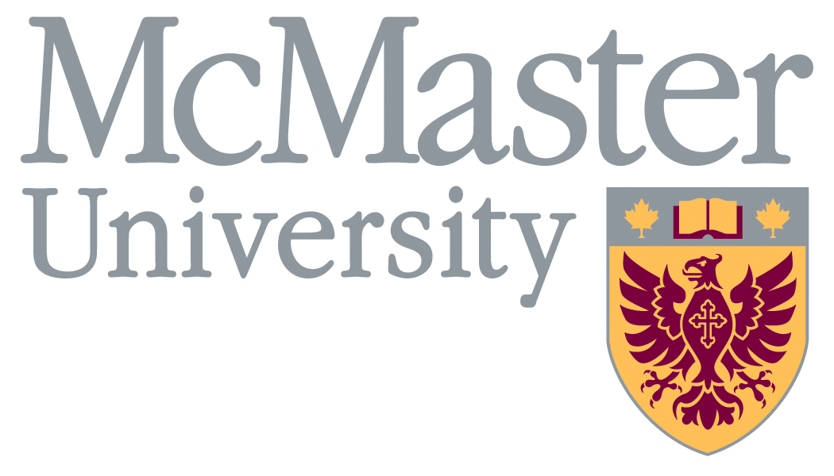
Summer Program
Application Form
a) Fill out form b) Save c) Attach to email d) Send to leegsmp@mcmaster.ca
OR a) Fill out form b) Print c) Sign d) Mail/Fax (see address/fax below)

General Information

_________________________________________________________________
Family Name Given name Male Female

______________________________________________________________________________________
Date of Birth (year/month/day)

______________________________________________________________________________________
Mailing Address

______________________________________________________________________________________
City Province

______________________________________________________________________________________
Country Postal Code
______________________________________________________________________________________
Home Phone Number Mobile Phone Number

______________________________________________________________________________________
Email WeChat ID (only used for correspondence after arrival)

Academic Information
From  (Year) | To  (Year) | Name of University / College Attended | Country | Level  Completed

Program Dates and Fees (please mark the program for which you wish to apply)
Summer English & Cultural Immersion Program

Four weeks July 2 – July 30, 2023 $4,300.00 CAD

Three weeks July 9 – July 30, 2023 $3,900.00 CAD

Two weeks July 16 – July 30, 2023 $3,400.00 CAD

Optional Eastern Canada Tour* To be announced
All program fees include: tuition, accommodation, meal card**, daily excursions, welcome and graduation ceremony, university health insurance, airport pick-up/drop-off and access to university facilities. If possible, dates may be customized upon request.
* Eastern Canada Trip fee will be posted asap.
** meal card value will vary by program and will only partially cover your overall meal costs

Payment Information
A non-refundable deposit of $300 CAD (or the entire tuition fee) must be paid with this application form. Please check our website for online payment options: https://oia.mcmaster.ca/summer-esl. Payment is due by June 15, 2020.

Letter of Acceptance
Please send my Letter of Acceptance via regular airmail
Please send my Letter of Acceptance via courier (FedEx) - additional $50 CAD should be enclosed

Please complete and send to us before May 31, 2023
By Mail: McMaster University By Fax: 001 (905) 546-5212
Office of International Affairs
1280 Main Street W. AMH 203 By Email: oia@mcmaster.ca
Hamilton, Ontario chenmay@mcmaster.ca
CANADA
L8S 4K1

Applicant Agreement
A registration deposit of at least $300 CAD must be sent with this application. The deposit is non-refundable unless your visa application is refused by the Canadian Embassy. In this case, please provide us with proof of refusal and your registration fee will be refunded, minus a $50 CAD administration fee.
McMaster University reserves the right to make changes in fees, schedules, and courses without notice, and, to cancel courses if enrollment is insufficient. If a course is cancelled, the full amount of fees paid will be refunded.
I hereby certify that all statements made on this application form are correct and complete. I understand that I may have to provide documentation at some future date to substantiate my claims and that any misrepresentation may result in the cancellation of my admission or registration status.

Applicant’s Signature: ______________________________ Date:________________________

